Roval CLX 50

Deeper, aero-focused wheels are the standard in the peloton these days while riders are not willing to sacrifice much weight for this aero advantage. Between our fastest CLX 64 setup and our lightest CLX 32 setup, we saw an opportunity to provide riders with another advantage. The Roval CLX 50 is the ultimate balance of light weight, aerodynamics and confident handling. It has best in class weight and better crosswind performance than other leading mid-depth wheels on the market.

WHAT WERE THE GOALS?
The goal of this project was to create a wheelset in the 45-55mm depth with a sub-1,400g weight (rim/clincher) that maximized the aero performance for that depth. We also needed to implement tubeless compatibility and a wide rim inner profile as well. This wheel would have to glean from the lightweight development of the CLX 32 and our aero expertise from the CLX 64 to create what we like to call “the unicorn wheel”. Ultimately, we wanted to ensure that regardless of the course or conditions, with the CLX 50s, you would have either the perfect wheel or make be making minimal concessions to the ideal theoretical equipment choice.

HOW DID WE DO IT?
With these goals in mind, and recent experience from both the CLX 64 and 32 under our belt, we began tinkering with rim geometries that would result in a lightweight design.

Lightweight design
- We performed varying weight and structural studies for rims of different depths, ultimately deciding that meeting our strict weight target would be a big gamble with a wheel over 50mm deep. Once a rim shape was decided on, we implemented every trick we learned from the CLX 32 development, along with additional testing and iteration to arrive at a light, yet durable rim.
- For the disc brake clincher, we freed ourselves from a rim brake track and the associated material and construction it requires. We utilized more impact resistant material and a unique layup to measurably improve impact strength. This also resulted in a rim that is up to 20g lighter than the corresponding rim brake rims.
- We anchored the rims to the newly developed Roval AF (Aero Flange) hubs. With our hub’s wide bracing angles and our 2:1 lacing pattern, we could strategically reduce spoke weight while maintaining the same lateral stiffness and durability that is required of all Roval wheels. Because of this, the CLX 50 family of wheels is incredibly light. Compared to leading competitors in this space, the CLX 50 is substantially lighter in every case.

CLX 50 Models | Set Weight (g)
Rim Brake | 1,375
Disc Brake | 1,415
Tubular | 1,230

RIM BRAKE (Clincher) MODELS | Set Weight (g) | DISC BRAKE (Clincher) MODELS | Set Weight (g)
Roval CLX 50 | 1,375 | Roval CLX 50 Disc | 1,415
Enve SES 4.5 | 1,526 | Enve SES 5.6 Disc | 1,528
Bontrager Aoelus 5 | 1,440 | Bontrager Aoelus 5 Disc | 1,558
Zipp 303 NSW | 1,425 | Zipp 303 Firecrest Disc | 1,645
Zipp 454 NSW | 1,525 | Zipp 404 Firecrest Disc | 1,715

Aerodynamic Development
Armed with the industry’s leading aero minds and testing technology, we delivered a wheel that has measurably better aerodynamic performance than the other leaders in this space. In the competitive range of mid-depth wheels, it’s remarkable that the CLX 50 shows clear improvement over its competitors.
- Combined with comprehensive structural and weight analysis of different rim geometries, we performed CFD simulations for rims of varying depths and shapes. The deepest rims weren’t always the fastest, and the shallowest rims weren’t necessarily the lightest. After days of constant CFD simulation, and iterative adjustments, we had narrowed the rim shape to the top 3 contenders. These shapes were precision CNC machined into rims, built into wheels, and put into the Specialized Win Tunnel for validation.
- Aero design of a rim turns out to be incredibly nuanced. Width, curvature, or brake track angle adjustments that are barely visible to the eye can turn out to perform noticeably different. Additionally, tire selection can have a dramatic effect on a wheel’s performance. Our CFD simulations and resulting Win Tunnel testing were all done around a Specialized S-Works Turbo 24c tire (measuring ~26mm wide).
- Similar to our development path on previous wheels, the tubular rim shape was iterated and scaled from the clincher version for optimal performance with tubular tires and how their shape interacts with a rim.
- While the rim itself is a substantial factor in the wheel’s aerodynamic performance, we could not have achieved this level of performance without the use of our Roval AF series hubs and DT Swiss aero spokes. These hubs were designed in the Win Tunnel and debuted on the CLX 64 wheels. The DT Swiss Aerolite spokes have proven to be a measurable gain over round spokes, yet the move to external nipples has not proven detrimental to aerodynamics.
(supporting aero graphs are at the end of this document)

WHAT ELSE IS NOTEWORTHY ABOUT THE CLX 50 WHEELS?
CeramicSpeed Bearings
As with all Roval CLX level wheels, CLX 50s come equipped with Ceramic Speed bearings. These bearings are the real deal – an aftermarket upgrade for the bearing kit would cost as much as $600 if purchased separately. In lab testing, CeramicSpeed bearings have shown an appreciable power savings over traditional steel bearings. When every watt counts and you’re counting on top tier performance, this is a necessary addition to these premium wheels.
Modern features: Wide & Tubeless
- Wide tires are more comfortable, provide better traction and can have lower rolling resistance than a narrow one. Lower pressures can improve these things even more. The CLX 50 has an inner rim width of 20.7mm which helps with tire support and enhances these features even more. When you corner or lean the bike, the tire is better supported by the wider rim.
- The CLX 50 is also tubeless compatible. Super lightweight tubeless plugs easily snap into place and seal each spoke hole individually. Every wheel ships with these tubeless plugs and an alloy valve stem so there is no added cost for tubeless setup (Tape from a variety of manufacturers can be used as well if someone prefers that setup).
Rider Friendly
- External nipples are featured on every wheel. Minor truing adjustments can be made on tubular or tubeless setups without having to remove the tire.
- Hub internals are DT Swiss’ reliable and easily serviceable DT Swiss 240s Star-Ratchet variety. The hub system requires no special tools to take apart or service and replacement parts are easy to source.
- Roval wheels have easily interchangeable end caps and freehub bodies for adaptable and futureproof wheels. All rear wheels ship with 11sp Road freehub bodies that are compatible with SRAM and Shimano cassettes. Campagnolo or SRAM XD freehub bodies are available aftermarket. Disc brake wheels ship with endcaps for QR and 12mm thru axles (12x100mm front, 12x142 rear).
- Wheels also ship with any compatible skewers, Swiss Stop brake pads, tubeless plugs + valves, and a padded wheel bag.

AERO DATA:
The Roval CLX 50 is marginally, yet measurable faster than Zipp’s recently introduced 454 NSW while being lighter as well. It aero performance closely mimics the CLX 64 at low yaw angles and performs exceptionally well compared to shallower wheels as the yaw angle increases.

Testing notes:
* Tests were performed with a rim brake clincher front wheel alone. Previous WinTunnel testing has shown the deltas between bike + wheel and wheel alone testing to be consistent.
* The same tire and pressure was used for all testing – a Specialized Turbo Cotton 24c @ 100psi. (Actual measured width is noted in the graph)
* Tests were performed multiple times and the results were averaged.
* Roval disc brake wheels have been tested separately and have the same deltas from their rim brake counterparts. Disc brake wheels from Zipp were not tested and information for them should not be extrapolated for direct comparison.

AERO GRAPHS & DEFINITIONS
Translational Drag
Traditionally talked about when referring to how “aero” something is; this is what a typical wind tunnel measures and what everyone in the industry reports. It’s how hard the wind is pushing back on you when you’re riding. When viewed on a line graph, the lower the line, the faster you go.
Rotational Drag
When a wheel spins, additional aero drag is generated by the churning of the spokes and the rotation of the rim, tire, and hub through the air. Think of it this way: if you spin a wheel in your hand, even without going anywhere, it would still take some effort to keep it going because of this rotational drag. This is an additional force that the industry doesn’t usually measure even though it’s very real and can be a sizeable portion of the drag you feel.
Combined Drag
This is translational drag combined with rotational drag. It is the most complete representation of the total aero performance of a wheel. Same idea on a line graph; the lower your line, the faster you will go.
Yaw
The direction that you feel the wind hitting you from. On a line graph, 0 degrees means wind is blowing dead-nuts at your face – or there’s no additional wind, apart from the speed you’re traveling. 15 degrees means the wind is coming slightly from the side – a crosswind. It’s important to have a range as it’s rare that you are riding straight into the wind.
Aerodynamic Drag (C_{d}A)
This is the measurement used to quantify the aerodynamic resistance that you experience riding. It is made of two components: C_{d} and A. “C_{d}” is the coefficient of drag – which is controlled by the shape of an object. ‘A’ is the frontal area of the object being measured. The combination, C_{d} A, represents the total aero drag performance of the object (the industry standard unit for C_{d}A is m²). The lower this value is, the faster you go.

TRANSLATIONAL DRAG – Traditional tunnel drag chart
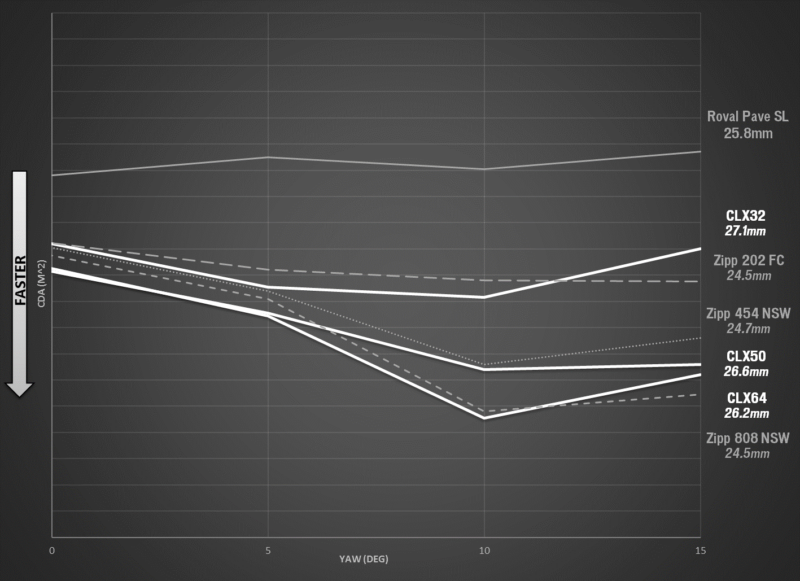
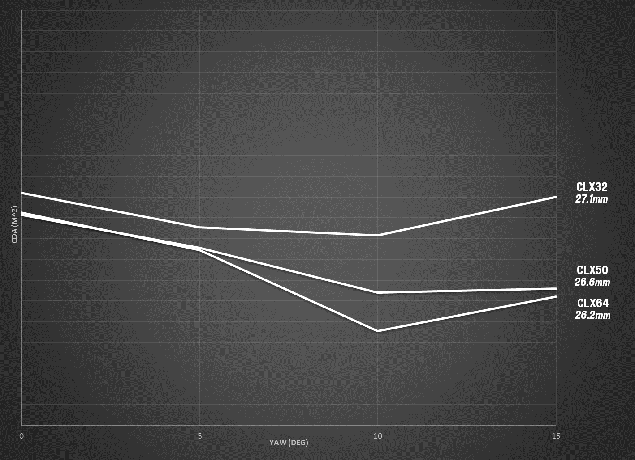

COMBINED (Translational + Rotational Drag)
